Ideation Phase Empathize & Discover

Date | 31 October 2025
Team ID | NM2025TMID07433
Project Name | Laptop Request Catalog Item
Maximum Marks | 4 Marks

Empathy Map Canvas:

In this phase, the team observes how employees and IT administrators handle laptop requests within the organization. They discover that employees often face confusion and delays due to the manual and unstructured process of submitting laptop requests. Many users are unsure about the required details, such as justification or accessories, and IT admins struggle to manage and track multiple requests efficiently.

Through interviews and feedback sessions, the team learns that the lack of a clear, automated system causes communication gaps, data entry errors, and slow approvals. Gathering these insights helps the team understand the real challenges faced in managing hardware requests. This understanding highlights the need for a ServiceNow-based catalog item with dynamic fields, UI policies, and automated workflows to make the process faster, more accurate, and user-friendly.

Example:Laptop Request Catalog Item

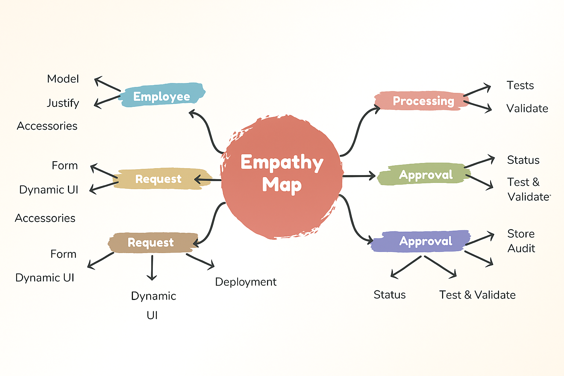

The empathy map helped us understand user challenges when deleting assigned users. It shows their pain, actions, and needs for better control and alerts. This guided us to design a safer system that prevents accidental deletion.

Example: Laptop Request Catalog Item

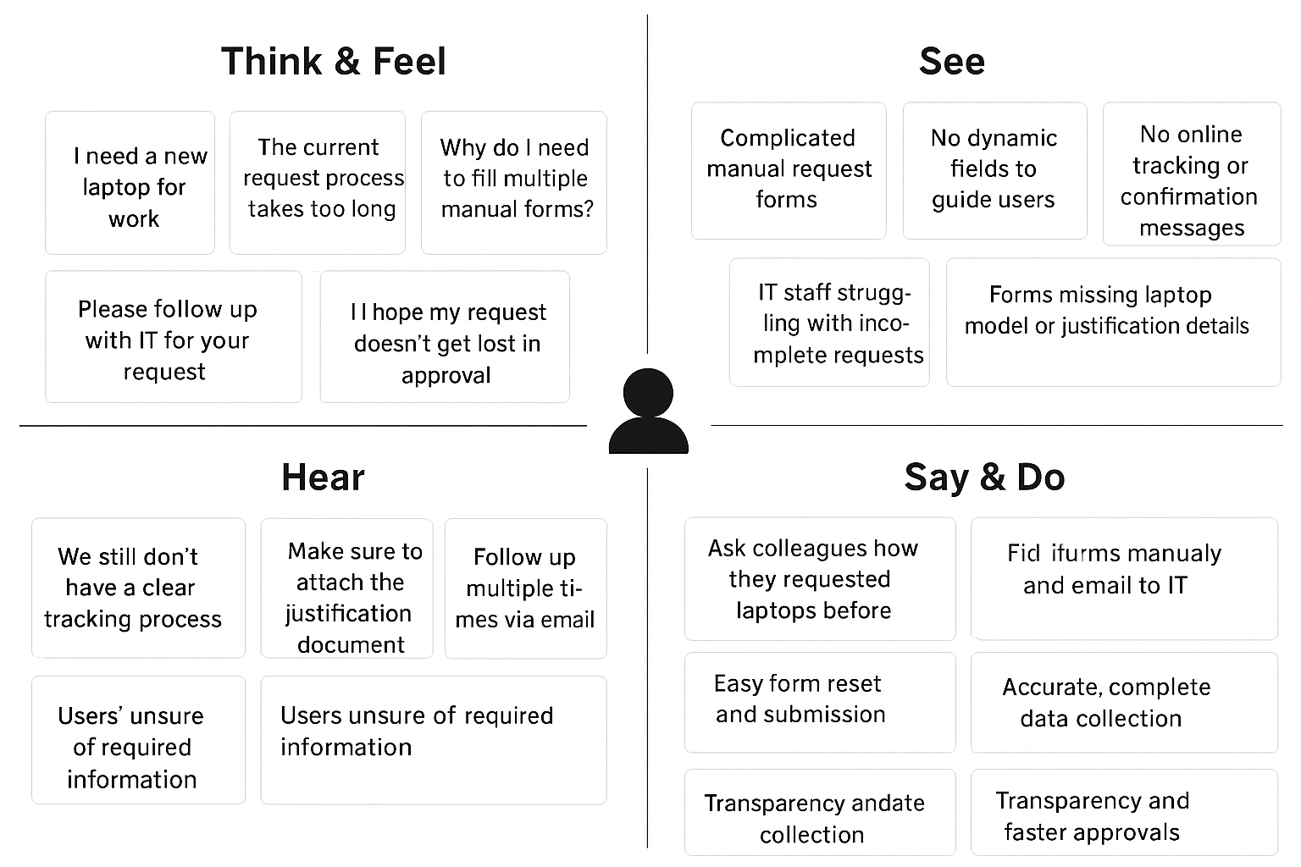
Through empathy mapping, we identified major user frustrations with the accidental deletion of incident-assigned users, including missing real-time alerts, unclear assignment visibility, and lack of preventive safeguards. To address these issues, we developed a secure and intelligent ServiceNow solution incorporating validation checks, confirmation prompts, and real-time tracking. This system ensures users linked to active incidents cannot be deleted unintentionally, thereby enhancing reliability, accountability, and overall user confidence in the incident management process.

